VOLUNTEERS NEEDED
FOR AN IMAGING RESEARCH STUDY

Did you have an imaging study that revealed narrowing of a blood vessel in your brain? Join our groundbreaking research study that will image the vessels in your brain using positron emission tomography-magnetic resonance imaging (PET-MRI).
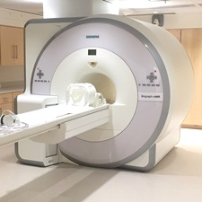
You may be eligible if you are between ages 18 to 88 years, have a history of narrowing of a blood vessel in your brain, and are able to have an MRI exam.

What's Involved?
One PET-MRI scan of the brain, an injection of a standard contrast agent used for routine MRI exams, and an injection of a PET imaging agent.

Location:
Health Sciences Research Facility III (HSF III)
670 W Baltimore St, Baltimore, MD 21201

Compensation:
You will receive $400 compensation and a parking voucher for participating in this study
There is no cost to you for any of the procedures

CONTACT US TODAY!
To learn more and see if you qualify, please contact Wenjie (Jenny) Yang
Email: wenjie.yang@som.umaryland.edu; Phone: 609-285-7976

